[**IMPLEMENTING WEB APPLICATION**](https://careereducation.smartinternz.com/Student/guided_project_workspace/3903#collapse2)

Create UI To Interact with Application

|  |  |
| --- | --- |
| Date | 8th November 2022 |
| Team ID | PNT2022TMID38955 |
| Project Name | Plasma Donor Application |

**Login.html**

<!DOCTYPE html>

<html lang="en">

<head>

<title>LOGIN_PAGE</title>

<meta charset="utf-8">

<meta name="viewport" content="width=device-width, initial-scale=1">

<link rel="stylesheet" href="https://maxcdn.bootstrapcdn.com/bootstrap/3.4.1/css/bootstrap.min.css">

<link rel="stylesheet" href="https://cdnjs.cloudflare.com/ajax/libs/font-awesome/4.7.0/css/font- awesome.min.css">

<script src="https://ajax.googleapis.com/ajax/libs/jquery/3.6.0/jquery.min.js"></script>

<script src="https://maxcdn.bootstrapcdn.com/bootstrap/3.4.1/js/bootstrap.min.js"></script>

<style>

.nav.navbar-nav{ margin-left: 900px;

}

.navbar-brand{ font-size: 22px;

}

.footer{ overflow: hidden;

background-color: #333; position: fixed;

bottom: 0; height: 65px; width: 100%;

}

input[type=text], input[type=password] { width:500px;

padding: 12px 20px; margin: 8px 0; display: inline-block;

background-color: black; opacity: 65%;

color: white;

border: 1px solid #ccc; box-sizing: border-box; border-radius: 10px;

}

button {

background-color: #04AA6D; color: white;

padding: 14px 20px;

margin: 8px 0; border: none; cursor: pointer; width: 250px; border-radius: 10px;

}

button:hover { opacity: 0.8;

}

.imgcontainer { text-align: center;

}

img.avatar {

border-radius: 50%;

}

.ayya {

padding: 16px;

}

label{

margin-left:-400px;

}

</style>

</head>

<body style="background-image: linear-gradient(to right, #dee4e6, #366060);">

<nav class="navbar navbar-inverse">

<div class="container-fluid">

<div class="navbar-header">

<a class="navbar-brand" href="#"><b>PLASMA DONOR APPLICATION</b></a>

</div>

<ul class="nav navbar-nav">

<li><a href="index.html">Home</a></li>

<li class="active"><a href="login.html">Login</a></li>

<li><a href="register.html">Register</a></li>

</ul>

</div>

</nav><br><br><br><br>

<div style="margin-top:-55px;" class="container">

<form action="index.html" method="post">

<div class="imgcontainer">

<img src="image.jpg" alt="plasma" class="avatar" width="120px" height="120px">

</div>

<center>

<div class="ayya">

<label for="uname"><b>USERNAME</b></label><br>

<input type="text" placeholder="Enter Username" name="uname" required><br>

<label for="psw"><b>PASSWORD</b></label><br>

<input type="password" placeholder="Enter Password" name="psw" required><br><br>

<button type="submit">LOGIN</button><br>

<div class="action">

<span class="load" onclick="openRegPage()" id="reg-action">

<button><a href="index.html">BACK</a></button>

</span>

</div>

<label>

<input type="checkbox" checked="checked" name="remember"> Remember me

</label><br>

</div>

</center>

</form>

</div>

</body>

</html>

# Output:

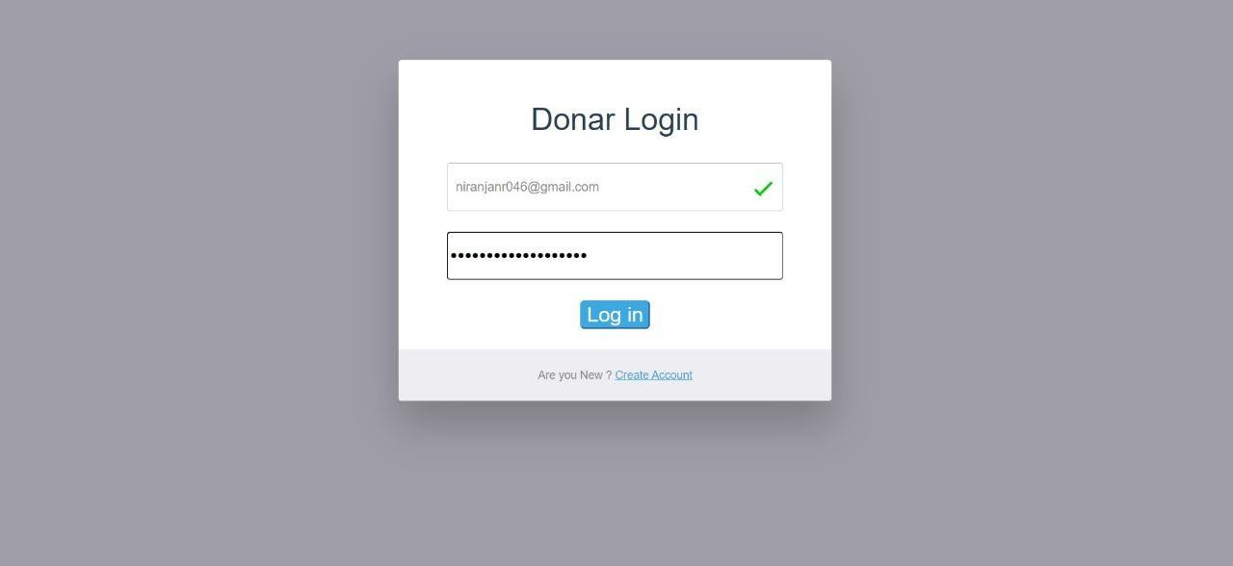

**Register.html:**

<!DOCTYPE html>

<html lang="en">

<head>

<title>REGISTERATION_PAGE</title>

<meta charset="utf-8">

<meta name="viewport" content="width=device-width, initial-scale=1">

<link rel="stylesheet" href="https://maxcdn.bootstrapcdn.com/bootstrap/3.4.1/css/bootstrap.min.css">

<link rel="stylesheet" href="https://cdnjs.cloudflare.com/ajax/libs/font-awesome/4.7.0/css/font- awesome.min.css">

<script src="https://ajax.googleapis.com/ajax/libs/jquery/3.6.0/jquery.min.js"></script>

<script src="https://maxcdn.bootstrapcdn.com/bootstrap/3.4.1/js/bootstrap.min.js"></script>

<style>

.nav.navbar-nav{ margin-left: 900px;

}

.navbar-brand{ font-size: 22px;

}

.footer{

overflow: hidden; background-color: #333; position: fixed;

bottom: 0; height: 65px; width: 100%;

}

input[type=text], input[type=password] { width:500px;

padding: 12px 20px; margin: 8px 0; display: inline-block;

background-color: black; opacity: 65%;

color: white;

border: 1px solid #ccc; box-sizing: border-box; border-radius: 10px;

}

button {

background-color: #04AA6D; color: white;

padding: 14px 20px; margin: 8px 0; border: none; border-radius: 10px; cursor: pointer; width: 250px;

}

button:hover { opacity: 0.8;

}

.imgcontainer { text-align: center;

}

img.avatar {

border-radius: 50%;

}

.ayya {

padding: 16px;

}

label{

margin-left:-400px;

}

</style>

</head>

<body style="background-image: linear-gradient(to right, #DECBA4, #3E5151);">

<nav class="navbar navbar-inverse">

<div class="container-fluid">

<div class="navbar-header">

<a class="navbar-brand" href="#"><b>PLASMA DONOR APPLICATION</b></a>

</div>

<ul class="nav navbar-nav">

<li><a href="index.html">Home</a></li>

<li><a href="login.html">Login</a></li>

<li class="active"><a href="register.html">Register</a></li>

</ul>

</div>

</nav><br><br><br><br>

<div style="margin-top:-55px;" class="container">

<form action="index.html" method="post">

<div class="imgcontainer">

<img src="image.jpg" alt="plasma" class="avatar" width="120px" height="120px">

</div>

<center>

<div class="ayya">

<label for="uname"><b>Name :</b></label><br>

<input type="text" placeholder="Enter Username" name="uname" required><br>

<label for="psw"><b>Email id :</b></label><br>

<input type="text" placeholder="[usermail@gmail.com](mailto:usermail@gmail.com)" name="mail" required><br>

<label for="psw"><b>Password :</b></label><br>

<input type="password" placeholder="Enter Password" name="psw" required><br>

<label for="uname"><b>Age :</b></label><br>

<input type="text" placeholder="Enter age" name="uname" required><br>

<button type="submit">REGISTER</button><br>

<div class="action">

<span class="load" onclick="openRegPage()" id="reg-action">

<button><a href="index.html">BACK</a></button>

</span>

</div>

</div>

</center>

</form>

</div>

</body>

</html>

# Register.css:

body{

background-size:cover; background-color:#e4dfdf; margin:0px; padding:23px;

}

a{

text-decoration:none;

}

.container{ width:60%;

height:80%;

background-color:#d1c9c9; border-style: outset; position: absolute; left:50%;

top:49%;

transform:translate(-50%,-50%); border-radius:20px; display:flex;

justify-content: center; align-items:center;

}

.text-container{ position: relative;

top:-100px; padding-bottom:-50px; width:50%;

height:100%; display:flex;

flex-direction:column; justify-content: center; align-items: center; margin-left:700px; margin-bottom:-10px; top:-40px

}

.heading{

font-family:calibri; color:rgba(30,30,30,1); align-items:center; left:80px ;

}

.text{ width:350px; height:50px;

border-radius: 50px; display:flex;

justify-content: center; align-items:center; margin:10px;

}

.text input{ height:40px; width:80%; outline:none; border:none;

justify-content: center; font-size:14px; margin:5px;

}

.trems{

top:20px ; position: relative; left:37px ;

display: flex;

}

.conditions a{ color:#7d22e3; font-weight:500;

}

button{ width:200px; height:40px; outline:none; border:none; border-radius:20px;

background:linear-gradient(-30deg,#3b02ed,#8e2ae0 55%); box-shadow:2px 6px 16px rgba(66,57,238,0.3); color:#FFFFFF;

font-weight:600; letter-spacing:1px; font-weight: 13px;

}

button:active{ transform:scale(1.1);

}

.text-container p{ width:70%;

text-align: center; font-family:arial; font-size: 15px; font-weight: 400; line-height:0px;

}

.toop{

position: relative; top: 20px;

left: 75px;

}

.check{

position: relative; top: -8px;

left: -5px;

}

# Output:

